Have your say!
The Housing Executive is seeking views on our Draft Homelessness Strategy 2022-27: ‘Ending Homelessness Together’ and our Draft Strategic Action Plan for Temporary Accommodation 2022-27: Homeless to Home’. Both documents are available on the consultations page of the Housing Executive website.
To gather views we are holding a full public consultation exercise that includes:
- The facility to submit written responses via the consultations page of the Housing Executive website.
- A series of virtual consultation events that will be facilitated online through the ‘Cisco WebEx’ platform. There will be separate consultation events for the draft Homelessness Strategy and for the draft Strategic Action Plan for Temporary Accommodation with details as follows:

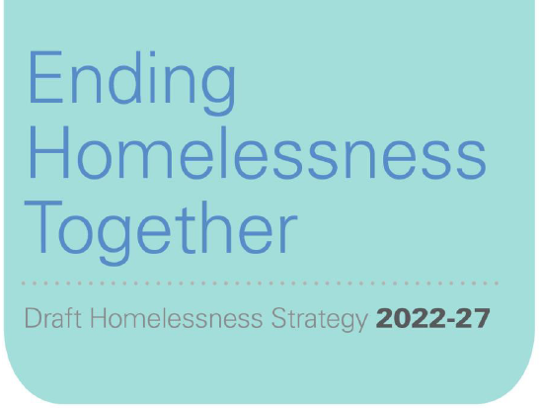
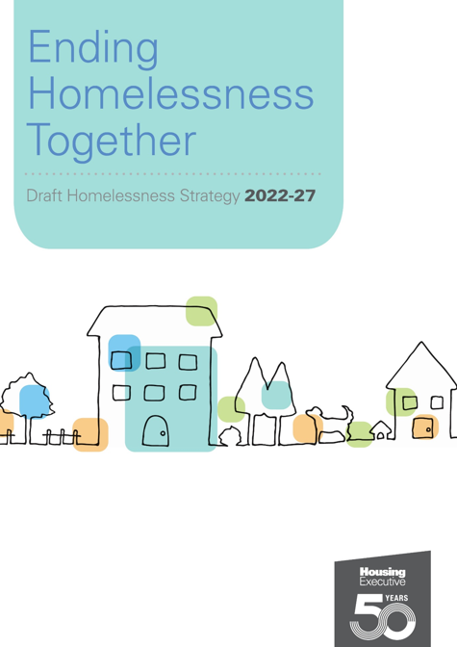
Draft Homelessness Strategy (2022-27)
- Fri 19th November 2021 @ 1:30pm
- Thu 25th November 2021 @ 10:00am
- Mon 29th November 2021 @ 10:00am
- Mon 13th December 2021 @ 2:00pm
- Wed 12th January 2022 @ 10:00am

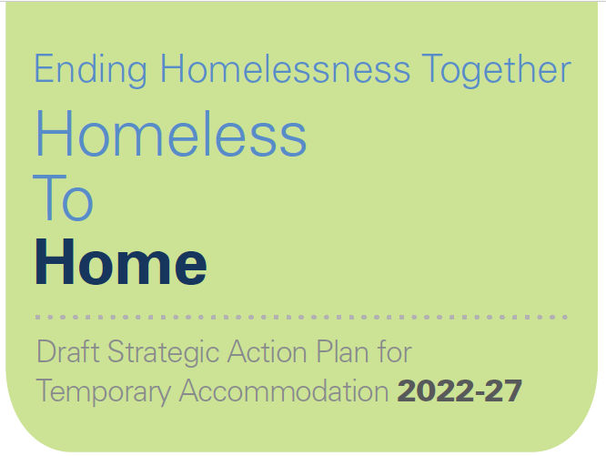
Draft Strategic Action Plan for
Temporary Accommodation (2022-27)
- Fri 26th November 2021 @ 2:00pm
- Wed 1st December 2021 @ 10:00am
- Wed 15th December 2021 @ 2:00pm
- Mon 12th January 2022 @ 10:00am

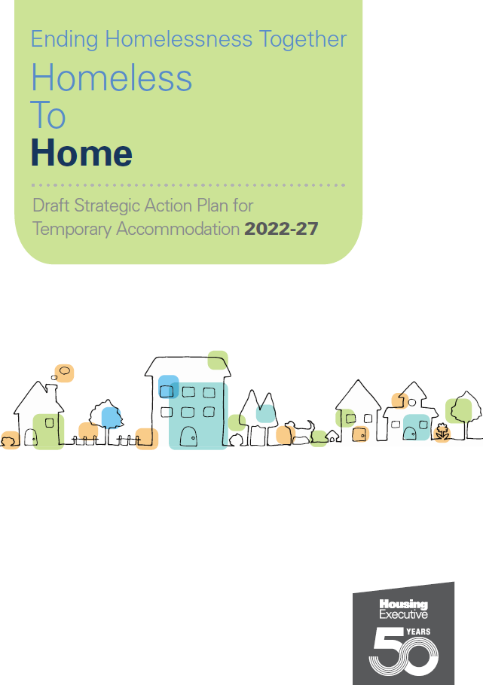
To register your interest in attending any of the virtual consultation events, please contact us through Homelessness.strategy@nihe.gov.uk and provide the following details for all attendees:
Name |  | Organisation
E-mail address |  | Preferred event date

Places for each event will be limited and allocated on a first come first served basis. A small number of individual tailored sessions on Homeless to Home also available on request.

