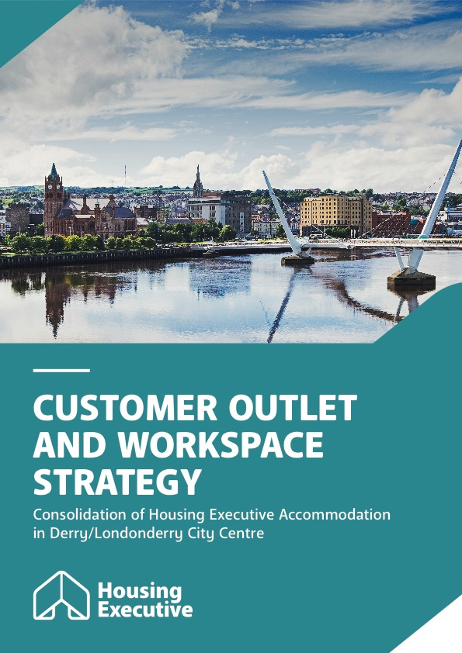

Customer Outlet and Workspace Strategy

Consolidation of NIHE Office Accommodation in Derry/Londonderry City Centre­­

Through our Customer Outlet and Workspace Strategy, we are reviewing all our office accommodation requirements across Northern Ireland in a structured manner between 2023/24 and 2028/29.

We aim to provide excellent services for all our customers, placing their needs at the centre of everything we do. We therefore need to ensure that our workspaces and customer outlets continue to meet the needs of our tenants, customers and our people. As a public sector landlord and the Strategic Housing Authority for Northern Ireland it is also essential that we ensure that we make the best use of tenant and public monies. Our customers habits and preferences have significantly changed in recent years with a circa 70% reduction in footfall over the last decade.

We have already brought together teams and services in a number of locations across Belfast, and, in 2023, we consolidated our Lanyon Place and Adelaide Street offices. We also consolidated our NIHE Direct operations (formerly our DLO) into a new facility in Newtownabbey. We have now developed plans to consolidate our office accommodation in Derry/Londonderry into a new single location at Carlise House, Carlisle Road, in the City Centre.

To ensure that all stakeholders have the opportunity to inform our next steps, we are now launching an 8-week consultation exercise.

We would welcome your feedback on the impact of these changes so that we can consider these along with any mitigations as appropriate.

Through our initial equality screening we did not identify any significant equality impacts. Based on our experience of similar changes we anticipate only minimal adverse impacts to our tenants, customers and our people.

We therefore encourage you to read the information provided in this document and, using the questions at the end of the document, share your thoughts by sending them to us at [tony.steed@nihe.gov.uk](mailto:tony.steed@nihe.gov.uk) or by post to NIHE Adelaide Street, Belfast BT2 8PB by 9th June 2025.

Why are we doing this?

In 2022 we developed a new strategy committing us to review all our office accommodation over a five-year period (23/24 – 28/29). This new Customer Outlet and Workspace Strategy was equality screened and widely shared.

Through a structured approach we are reviewing all of our office accommodation across Northern Ireland.

In June 2023 we consolidated our Lanyon and Adelaide Street offices in Belfast. We are currently finalising plans for our South Region and will be commencing a review of our accommodation for the rest of North Region. In addition, in September 2023, we also consolidated our Belfast Maintenance operations into one facility in Newtownabbey.

There are a number of reasons for reviewing all of our workspaces and customer outlets including:

* We want to ensure that our workspaces and customer outlets still meet the needs of our people, tenants and customers.
* How our customers interact with us has changed and is changing. Telephone and digital communication channels are continuing to grow, while footfall figures have fallen by circa 70% over 10 years.
* April 2015 to March 2016 – 305,000
* April 2019 to March 2020 – 184,000
* April 2024 to March 2025 – 88,000
* Many of our buildings are old (averaging 60 years) and are no longer fit for purpose.
* We have also changed how we work: through our new flexible working arrangements supported by changes in technology. Even prior to our change in working practices, many of our buildings were under occupied.
* We want to have workspaces and customer outlets that:
  + Support our culture, values and working practices
  + Promote Health and Well-being
  + Support Equality, Diversity and Inclusion.
  + Reduce our carbon footprint and support our sustainable development strategy.
* We also need to ensure the best use of tenant and public monies and that we comply with the Northern Ireland Asset Management Strategy along with other relevant policy and legislation.

What are our plans for our work in Derry/Londonderry?

As is the case throughout Northern Ireland, the reasons described above also apply in Derry/Londonderry.

Footfall levels, i.e. the number of people who call into our offices, have also fallen significantly, again with a circa 70% reduction over 10 years.

* April 2015 to March 2016 – 32,744
* April 2019 to March 2020 – 18,788
* April 2024 to March 2025 – 10,279

We currently have four offices in Derry/Londonderry.

**Richmond Chambers:** We have leased this building since 1985 and it currently accommodates our Housing, Housing Benefit, Placeshaping and Grants Teams (circa 165 people). It is approximately 230 metres from our new location at Carlisle House.

**Waterloo Place:** We have leased this office since 1987. Here we provide our services for homeless presenters and general housing enquiries (circa 60 people). It is approximately 530 metres from our new location at Carlisle House.

**Collon Terrace and Waterside** (Glendermott Road): We have owned both of these buildings since 1987 and 1989 respectively. They are primarily used as base locations for our Patch Managers and Maintenance Officers, both roles are highly mobile (circa 20 people in each building). Collon is approximately 2.2 miles from Carlisle House, while the Waterside office is approximately 1 mile.

It is also important to note that during 2017 we centralised our homelessness services to Waterloo Place.

The total annual costs associated with the four buildings is **£1,064m** per annum.

**Note:** Collon Terrace is subject to a potential vesting order to facilitate the completion of the A2/Buncrana Road upgrade.

How do we make our decisions?

As we developed our Customer Outlet and Workspace Strategy, we established eight criteria that we would use to help us evaluate options for change. The eight criteria are as follows:

* Customer Engagement
* People/Culture/Working Practices
* Environmental
* Health, Safety and Well-being
* Value for Money
* NI Asset Management Strategy and Legislation
* Stakeholder Acceptability
* Future Proofed

We considered seven initial options as we reviewed our accommodation in Derry/Londonderry. Three options were taken forward to the Business Case (which is the formal proposition document) where Carlisle House became the preferred option.

Carlisle House:

* Best meets our criteria
* Provides good access for tenants, customers and staff
* Enables us to bring all of our people and services together in one place
* Ensures that we remain within the city centre.

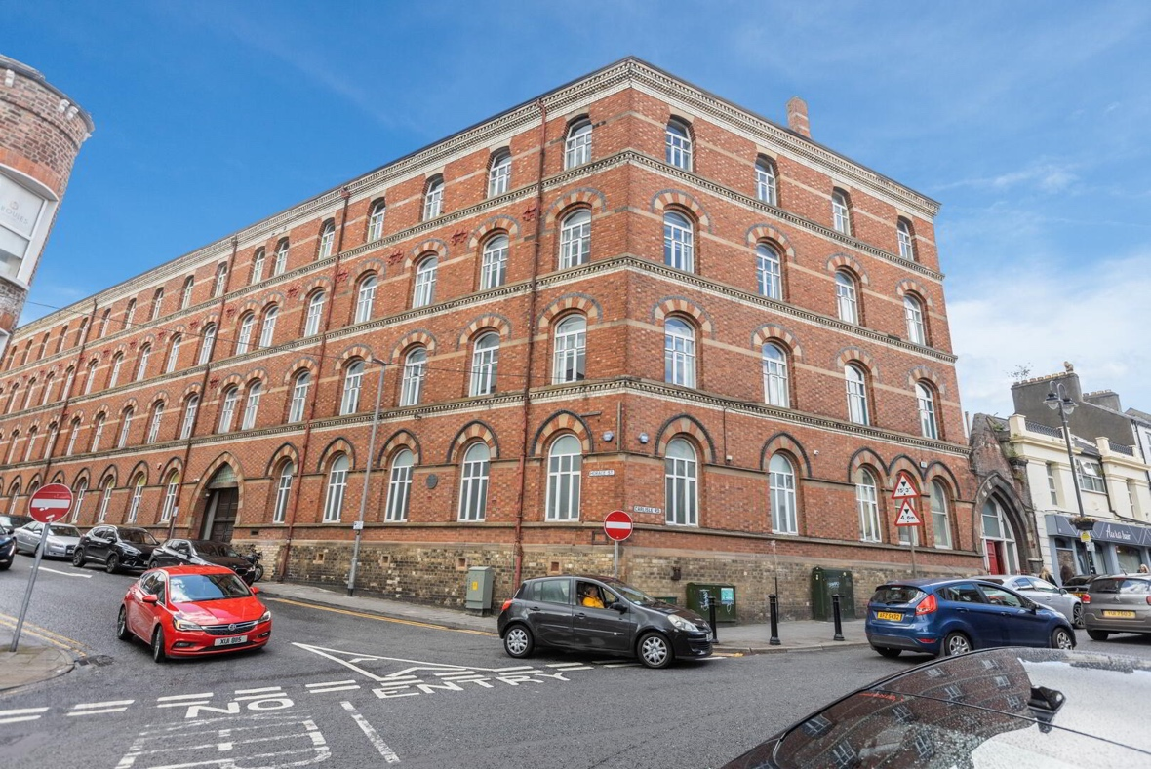

Benefits

We believe that consolidating our four offices into one central location at Carlise House will provide a number of benefits:

* **Access for tenants and customers:** The new city centre location is easily accessible for the majority of our tenants and customers. It is in the commercial and retail centre for the city with excellent transport links, only 530m from our existing office in Waterloo Place. It is an area which is accessible for the communities we serve.
* **Better use of limited resources:** Consolidating the offices will enable estimated savings of circa £3-4m over ten years, which can be reinvested in tenant and customer services.
* **Improved accommodation for our people, tenants and customers:** A new modern building will support our working practices, equality and the health & well-being of our people. It will also provide new, fit for purpose and improved meeting spaces for our tenants and customers. In addition, it will reduce our carbon footprint and improve energy efficiency.
* **Service provision and co-ordination:** The new building will allow all of our services to be provided from one central location and enable improved collaboration and joined up working between our various teams.
* **Possible alternative use for Collon Terrace and Waterside:** Consolidating our four offices may enable us to make better use of our buildings in Waterside and Collon Terrance (temporarily). We are currently considering alternative housing options for these sites.

Indicative Timescales

Our intention is to consolidate our workspaces and customer outlets in Derry/Londonderry city centre during this financial year. We anticipate that colleagues working in Richmond Chambers and Waterloo Place could move during August /September 2025, followed in due course by colleagues based in Collon Terrace and Waterside.

A street map showing the location of Carlisle House.

Accommodating Equality and other issues:

Our Equality Screening Team has conducted an analysis of the potential impact of these changes. We recognise our duty to pay due regard to our Section 75 obligations and to use this opportunity to optimise the promotion of equality of opportunity for those groups protected by this legislation for both our customers and staff.

Customers

Our customers will be familiar with the current office locations although the significant reduction in footfall at these offices and changes in our working practices (flexible/remote working) are key factors.

Our experience of changing office locations in other areas and the supporting evidence would suggest that this change will only have a minimal impact. Our customers use alternative methods of communication with us with limited reliance on visiting the office.

Our new location is in the heart of the commercial and retail part of the city, an accessible area, close to both city centre river crossings with good parking and transport links close.

Mitigation

Where a customer is unable to avail of our services using alternative methods of communication, for example, due to having a disability or other mobility issue, we will ensure that we will meet their needs in a timely way through proactive services such as a home visit.

In addition, our comprehensive communication support service is designed to address all sensory disability and linguistic barriers, and this can often be delivered remotely through mobile technology e.g. sign video (sign language).

Our People

Our initial screening has identified potential issues for staff who may have a disability, older staff with less mobility and staff who have caring responsibilities.

Mitigation

We recognise change can be difficult and pose practical challenges so we will consult with staff affected by this move to ensure individual concerns are considered.   We will manage this change through our Organisational Change Policy, and we will continue to support the health and wellbeing of our people through a wide range of policies including flexible working arrangements.

We will continue to monitor the impact of these changes on service delivery and on our people. We will ensure that any emerging issues are addressed appropriately. We anticipate that continued changes to technology will further improve accessibility to our services.

We would like to hear your views   
on this change

Consolidation of Housing Executive Accommodation in Derry/Londonderry City Centre

Consultation Response Template

|  |  |  |  |  |  |
| --- | --- | --- | --- | --- | --- |
| Your Details | | | | | |
| Is this submission on behalf of an: | | Organisation |  | Individual |  |
| Name: | Click here to enter text. | | | | |
| Organisation: | Click here to enter text. | | | | |
| Postal Address: | Click here to enter text. | | | | |
| Postcode: | Click here to enter text. | | | | |
| Email: | Click here to enter text. | | | | |

Please note that if a response is recorded on behalf of an organisation, the consultation response will include the name of the organisation while all individual responses will be anonymised as ‘individual’

|  |  |
| --- | --- |
| 1 | This consultation document outlines specific proposals to close four offices and replace them by consolidating all services in Carlisle House in the City Centre. Do you have any comments in relation to this plan and is there anything else you would like to see included? |
| Please add any additional comments: | |
| 2 | This project is necessary for a number of reasons including the need to improve our accommodation, respond to changes in how customers interact with us, ensure alignment with the Northern Ireland Asset Management Strategy and other relevant policy and legislation, while making the best use of tenant and public monies.  Are there any other issues or considerations you would like the Housing Executive to pay regard to in the implementation of this project? |
| Please add any additional comments: | |

|  |  |
| --- | --- |
| 3 | Having considered the two questions above, please provide any other comments or suggestions which you feel may be relevant to this project |
| Please add any additional comments: | |

Freedom of Information Act 2000 Confidentiality of Consultations.

The Housing Executive will publish a summary of responses following completion of the consultation process. Your response, and all other responses to the consultation, may be disclosed on request. The Housing Executive can only refuse to disclose information in exceptional circumstances. Before you submit your response, please read the paragraphs below on the confidentiality of consultations and they will give you guidance on the legal position about any information given by you in response to this consultation.

The Freedom of Information Act gives the public a right of access to any information held by a public authority, namely, the Housing Executive in this case. This right of access to information includes information provided in response to a consultation. The Housing Executive cannot automatically consider as confidential information supplied to it in response to a consultation. However, it does have the responsibility to decide whether any information provided by you in response to this consultation, including information about your identity should be made public or treated as confidential.

This means that information provided by you in response to the consultation is unlikely to be treated as confidential, except in very particular circumstances. The Lord Chancellor's Code of Practice on the Freedom of Information Act provides that:

The Housing Executive should only accept information from third parties in confidence if it is necessary to obtain that information in connection with the exercise of any of the Housing Executive's functions and it would not otherwise be provided.

The Housing Executive should not agree to hold information received from third parties "in confidence" which is not confidential in nature.

Acceptance by the Housing Executive of confidentiality provisions must be for good reasons, capable of being justified to the Information Commissioner.

For further information about confidentiality of responses please contact the Information Commissioner's Office - or see the website at: [**http://www.informationcommissioner.gov.uk/**](http://www.informationcommissioner.gov.uk/)