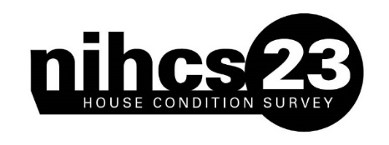    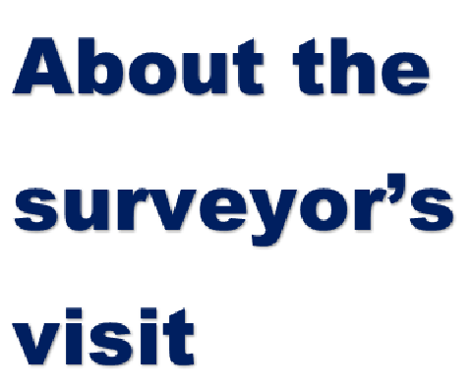   | Thank you for considering taking part in this survey. The last Northern Ireland House Condition Survey (NIHCS) was conducted in 2016. As before, this survey will collect information to help us plan for the future of housing in Northern Ireland.  The 2023 NIHCS is about to begin. The survey will give a full picture of the condition and energy efficiency of housing in Northern Ireland and will allow us to measure Energy Efficiency, Fuel Poverty and the Decent Homes Standard across Northern Ireland. Approximately 7,000 homes of all types will be included in the survey.    Is this survey just about homes owned by the Housing Executive and Housing Associations?  No. The survey covers all housing, whether it is owned or rented. Government money is spent, not only on public housing, but also on privately owned housing, in the form of grant aid. All types of housing, therefore, must be included in the survey to ensure proper planning for the future. The results will be used to help draw up a comprehensive housing policy aimed at meeting housing needs – both for tenants and for homeowners.  Why should I take part?  The quality of the information we collect depends on the co-operation of all the householders throughout Northern Ireland whose homes have been chosen for the survey. Due to the current economic climate, it is ever more important for limited resources available to Government to be directed most appropriately. A good response from individual householders is vital to the success of the survey, so your co-operation is greatly appreciated.

How was my home selected?  Due to limited resources it is not possible to inspect all homes in Northern Ireland; therefore your home has been selected in one of two ways. Homes included for the first time in the survey have been selected by a random process from the address database maintained by the Northern Ireland Statistics and Research Agency. This is the standard research selection technique.  The other homes included in the 2023 survey are homes inspected as part of the 2016 House Condition Survey. The re-inspection of dwellings from the previous survey allows us to measure how housing conditions have changed over time. This too is a vital aspect of the survey. | Who will see the information?  All information is strictly confidential and will be grouped into statistical tables for use in reports. It will be impossible to identify any individual or address, or to discover anyone’s personal circumstances.  How can this new survey help improve housing conditions in Northern Ireland?  A new survey is essential because we need to know if housing policies as shaped by earlier surveys are improving housing conditions and, if they are not, what modifications of policy would be most effective. | There is nothing wrong with my home. Why should I take part?  To obtain an accurate picture of all the housing in Northern Ireland, we need to examine all kinds of properties: flats and houses, urban and rural homes, owned and rented properties, older and more modern homes. If we omit any section of the housing stock, the overall picture will be misleading. So, even if your home is newly built, we still need your help.  When will the survey take place?  The survey is scheduled to start in May 2023 and finish in August 2023.
What happens when the surveyor calls at my home?  A qualified professional surveyor will carry out a physical inspection of your home and will also ask you to take part in a short interview. The surveyor will carry an identification card. The inspection should take about an hour to complete. The surveyor will record information about the amenities, services, fittings and state of repair of your home. He/she will carry out an inspection, both inside and outside the building, and, if you live in a block of flats, will also make a report on any communal areas. In addition to the physical inspection, you will be asked a number of questions about the household, including the number of people living there, their ages, and if they have any disabilities. This information will help the Housing Executive assess the housing needs of particular groups, such as older people and families with young children. |   In what way are the selected dwellings representative?  Each dwelling selected at random may be considered to represent approximately 120 dwellings in Northern Ireland. The fact that a particular dwelling is chosen in no way reflects the condition of that dwelling. Dwellings of different tenures, ages and conditions will be chosen to be representative of other dwellings in Northern Ireland. | I took part in the 2016 survey – Why should I do it again?  We are interested not only in the condition of housing in 2023, but how it compares with the situation seven years ago. The best way to discover this is to revisit some of the properties we examined in 2016. This will provide information about any change in stock condition, the housing market and the types of properties moving into and out of unfitness. Whether or not the condition of your home has changed, we need to include it to ensure the overall results are as accurate as possible.
What if I am out when the surveyor calls?  If you are out, the surveyor will leave an appointment card asking you to suggest a suitable time for him/her to call again. The surveyor will continue to try to contact you. If this is not possible, the surveyor will make an external inspection of your home in order to gather as much information about the property as possible for inclusion in the survey. Each dwelling has been chosen to represent a number of other dwellings, and so it is important that your home is included in the survey if at all possible.  What will the information be used for?  The survey findings will produce an up-to-date picture of housing conditions throughout Northern Ireland, which will also indicate the variation in conditions from area to area. This will help ensure that money invested in public and private housing is targeted and spent in the most beneficial way. | How will the survey results affect owner-occupiers?  Owner-occupiers, as well as tenants in both the public and private sectors, will benefit from the survey through the valuable information the survey results will provide. Information on the type, size and condition of housing in Northern Ireland will help house builders and private developers understand the requirements of owner-occupiers. Furthermore, the information will help with home improvement policies. | Will the results be published?  Yes. We will publish a report that will be available to the general public on the Housing Executive’s website. Reports from earlier surveys can be viewed and/or downloaded from the Housing Executive’s website www.nihe.gov.uk.  Thank you, in anticipation, for your co-operation in this vital research. If you have any queries, please phone the House Condition Survey helpline number on 02895 982548. The line is open Monday to Friday 10am to 4pm. For Relay UK please dial 18001 03448 920 900. A Video Relay Service (VRS) is also available. More information on these services can be found on our website.

