****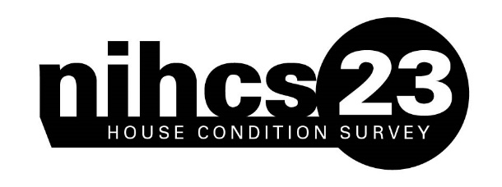

Help shape the future of housing

Dear Sir or Madam,

You’ve been selected to take part in the Northern Ireland House Condition Survey (NIHCS) – we hope we can count on your help in this important survey. Approximately every five years, a number of addresses across NI are chosen at random from the Northern Ireland Statistics and Research Agency (NISRA) Address Register (NAR). This is your unique chance to take part in this research.

The survey will help to shape the future of housing in Northern Ireland – improving the experiences of householders, guiding housing investment and maintenance strategies and providing reliable and consistent data for measuring energy efficiency and fuel poverty.

|  |  |
| --- | --- |
| C:\Users\Millar_r1\AppData\Local\Microsoft\Windows\INetCache\Content.Outlook\S9GKZ69A\What's next.png | What’s next?  One of our surveyors will call to your home in the next week or so. They will be carrying a photographic ID card. The surveyor will look at the inside and outside of your home, and ask you some questions about your household. You will also have the opportunity to ask our surveyor any questions about the condition of your home and improving energy efficiency. |
| C:\Users\Millar_r1\AppData\Local\Microsoft\Windows\INetCache\Content.Outlook\S9GKZ69A\What's next.png | Any questions?  If you have any questions please call the House Condition Survey helpline on 02895 982548 (Relay UK: 18001 03448 920 900) between 10am and 4pm Monday - Friday or e-mail [nihcs@nihe.gov.uk](mailto:nihcs@nihe.gov.uk). Alternatively, there is general information about the survey available on our website. Visit [The Housing Executive - Research (nihe.gov.uk)](https://www.nihe.gov.uk/working-with-us/research) |
| C:\Users\Millar_r1\AppData\Local\Microsoft\Windows\INetCache\Content.Outlook\S9GKZ69A\What's next.png | Thank you for your help  Your help will give us a better picture of housing conditions in Northern Ireland today along with helping to inform government allocation of financial resources. |

Yours faithfully,

**Ursula McAnulty** Head of Research

|  |  |
| --- | --- |
| Frequently Asked Questions | How did you choose my address?  We chose your address at random from the NISRA Address Register (NAR). The NAR is developed within NISRA and is primarily based on the Land & Property Services (LPS) [Pointer](https://www.nidirect.gov.uk/articles/pointer) database.  What is the survey about?  The surveyor will look at the physical characteristics of your home (inside and outside) and you will be asked some questions about your household. On average this visit will take around an hour to complete. If you are not home when the surveyor calls, a card will be left stating when to expect the surveyor’s call next, or giving you a phone number to make an appointment. Surveyors can call in the evenings and at weekends as well as during normal working hours. If you require a sign-language interpreter or translator, this can be arranged.  Who is carrying out the survey?  The Northern Ireland Housing Executive (NIHE) carries out this survey. The NIHCS is the internal team within the Northern Ireland Housing Executive and can be contacted by email at [nihcs@nihe.gov.uk](mailto:nihcs@nihe.gov.uk)  What will happen to any information I give?  The survey is confidential, your name does not appear on our database and your address will be kept separate from any information collected. The survey will only be used for research purposes. In line with other government bodies and current data sharing practices, the Housing Executive will archive some of the data (anonymised) with, for example, the UK Data Archive (University of Essex) in order to make them available to other researchers. The Housing Executive conforms to the principles of the **Data Protection Act 2018** (GDPR). You can view more information on data protection and privacy on the Housing Executive’s website [The Housing Executive - House Condition Survey (nihe.gov.uk)](https://www.nihe.gov.uk/working-with-us/research/house-condition-survey)  Do I have to take part?  Participation in the survey is voluntary. We hope that you will take part as we rely on the voluntary participation of householders to get a clear picture of housing in 2023, which will help us to shape the future of housing in Northern Ireland.  Where can I find out more?  Visit [The Housing Executive - Research (nihe.gov.uk)](https://www.nihe.gov.uk/working-with-us/research), e-mail [nihcs@nihe.gov.uk](mailto:nihcs@nihe.gov.uk) or telephone 02895 982548 between 10am and 4pm Monday – Friday. For Relay UK please dial 18001 03448 920 900a Video Relay Service (VRS) is also available. More information on these services can be found on our website. |