Public Consultation
Supporting People Draft Three Year Strategic Plan and COVID-19 Recovery Plan 2022-25

Please use the following link to submit your responses and comments via our online consultation questionnaire - https://consultations.nidirect.gov.uk/nihe/sp-plan-22-25
Alternatively, the consultation template below can be used for submitting your responses and comments.
The consultation document can be accessed at https://www.nihe.gov.uk/Working-With-Us/Partners/Consultations
If you are completing an electronic version of this form, it should be emailed to supporting.people@nihe.gov.uk.

For more details on the Strategic Plan 2022-25, please contact the Supporting People Policy, Strategy and Communications Team at: supporting.people@nihe.gov.uk

Alternatively, you if you would like to return hard copies of the completed form, please send to:
F.A.O Policy, Strategy and Communications Team
Supporting People
2nd Floor
2 Adelaide Street,
BELFAST
BT2 8PB

The Housing Executive Supporting People Team welcome any comments you wish to make on all of the proposals or just on those issues that are of particular interest to you in the consultation.
All responses should be received by 5pm on Monday 25th April 2022, to ensure they can be fully considered.

Freedom of Information Act 2000
Confidentiality of Consultations
The Housing Executive will publish a summary of responses following completion of the consultation process. Your response, and all other responses to the consultation, may be disclosed on request. The Housing Executive can only refuse to disclose information in exceptional circumstances. Before you submit your response, please read the paragraphs below on the confidentiality of consultations and they will give you guidance on the legal position about any information given by you in response to this consultation.
The Freedom of Information Act gives the public a right of access to any information held by a public authority, namely, the Housing Executive in this case. This right of access to information includes information provided in response to a consultation. The Housing Executive cannot automatically consider as confidential information supplied to it in response to a consultation. However, it does have the responsibility to decide whether any information provided by you in response to this consultation, including information about your identity should be made public or treated as confidential.
This means that information provided by you in response to the consultation is unlikely to be treated as confidential, except in very particular circumstances. The Lord Chancellor's Code of Practice on the Freedom of Information Act provides that:
- The Housing Executive should only accept information from third parties in confidence if it is necessary to obtain that information in connection with the exercise of any of the Housing Executive's functions and it would not otherwise be provided.

- The Housing Executive should not agree to hold information received from third parties "in confidence" which is not confidential in nature.

- Acceptance by the Housing Executive of confidentiality provisions must be for good reasons, capable of being justified to the Information Commissioner.

For further information about confidentiality of responses please contact the Information Commissioner's Office (or see the website at: http://www.informationcommissioner.gov.uk/ ).

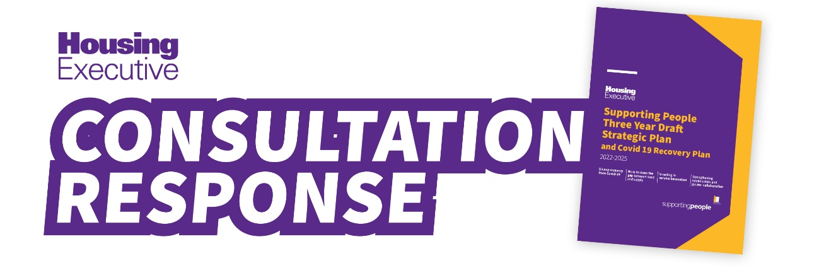

Your Details
Is this submission on behalf of an: |  | Organisation | ☐ | Individual | ☐
Name: | Click here to enter text.
Organisation: | Click here to enter text.
Postal Address: | Click here to enter text.
Postcode: | Click here to enter text.
Email: | Click here to enter text.

Please note that if a response is recorded on behalf of an organisation the consultation response will include the name of an organisation while all individual responses will be anonymised as ‘individual’

1 | Do you agree that the document provides a clear mission and strategic priorities for the Supporting People Programme? | YES  ☐ | NO  ☐
Further Comments: Click or tap here to enter text.

2 | Do you agree that the objectives of the document are clear? | YES  ☐ | NO  ☐
Further Comments: Click or tap here to enter text.

3 | Do you agree with the actions that we will take in order to address the challenges of Objective 1 (Covid19 Recovery)? | YES☐ | NO  ☐
Further Comments: Click or tap here to enter text.

4 | Do you agree with the actions that we will take in order to address the challenges of Objective 2 (Work to close the gap between need and supply)? | YES  ☐ | NO  ☐
Further Comments: Click or tap here to enter text.

5 | Do you agree with the actions that we will take in order to address the challenges of Objective 3 (Investing in service innovation)? | YES  ☐ | NO  ☐
Further Comments: Click or tap here to enter text.

6 | Do you agree with the actions that we will take in order to address the challenges of Objective 4 (Strengthening relationships and greater collaboration)? | YES  ☐ | NO  ☐
Further Comments: Click or tap here to enter text.

7 | Is there anything further you feel needs to be included in the strategy document? | YES☐ | NO  ☐
Further Comments: Click or tap here to enter text.

8 | If you have any other comments regarding the strategy document please detail these below.
Click or tap here to enter text.

